Nicholas Lee  Engineering Portfolio | n9lee@uwaterloo.ca  LinkedIn Website Portfolio
Mechatronics Engineering student at the University of Waterloo, recently a Research Intern at Harvard’s Aizenberg Lab (May – Aug 2026). Full case studies for each project below are on my website portfolio.

Influence of Geometry on Sensor Detection for an Adaptive Electronic Nose | COMSOL Multiphysics, CFD, Python, ITK-SNAP, MeshLab, Meshmixer
Investigated how nasal channel geometry affects sensor detection for an adaptive electronic nose at Harvard’s Aizenberg Lab, so the device can be biased toward a scent by adjusting channel geometry rather than sensor hardware. Built a parametric COMSOL model driven by a transient sniff cycle and ran 700+ transient cases spanning 19 bend angles, 13 stroke ratios, and 10 hydrocarbons, automating the analysis in Python (Pandas, NumPy, Matplotlib) into 11 metrics, 80+ figures, and 16 tables in one scripted step.
Completed the simulation campaign; benchtop validation is ongoing. The findings below are the simulations I ran and the initial analysis and conclusions I drew from them. Across the 247-case geometry grid, bending the channel proved a conditional detection lever: when the sniff stroke roughly matches the channel length, a full U-bend delivers up to 31% more odorant exposure and a 42% higher peak signal, while outside that band the effect turns into a penalty or vanishes. The early place map, which suggested each compound peaks at its own channel position, did not survive distribution-level statistics across 10 compounds and 100 probe positions, an informative negative result: every compound shares one optimal sensor location just inside the inlet, and compound identity is carried by the timing of the transient waveform, with selectivity shifting under 11% across bend angles. To extend the study to real anatomy, segmented CT-scanned animal airways in ITK-SNAP and repaired the meshes into watertight STLs in MeshLab and Meshmixer for benchtop validation.
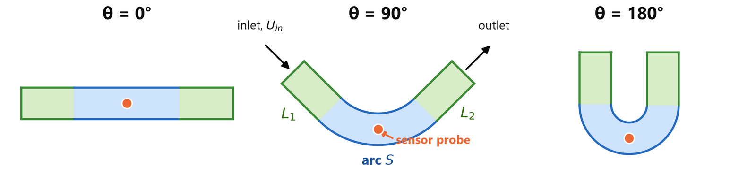
Parametric U-Channel Geometry: Bend Angle θ Opens the Channel While Width and Flow Path Stay Fixed
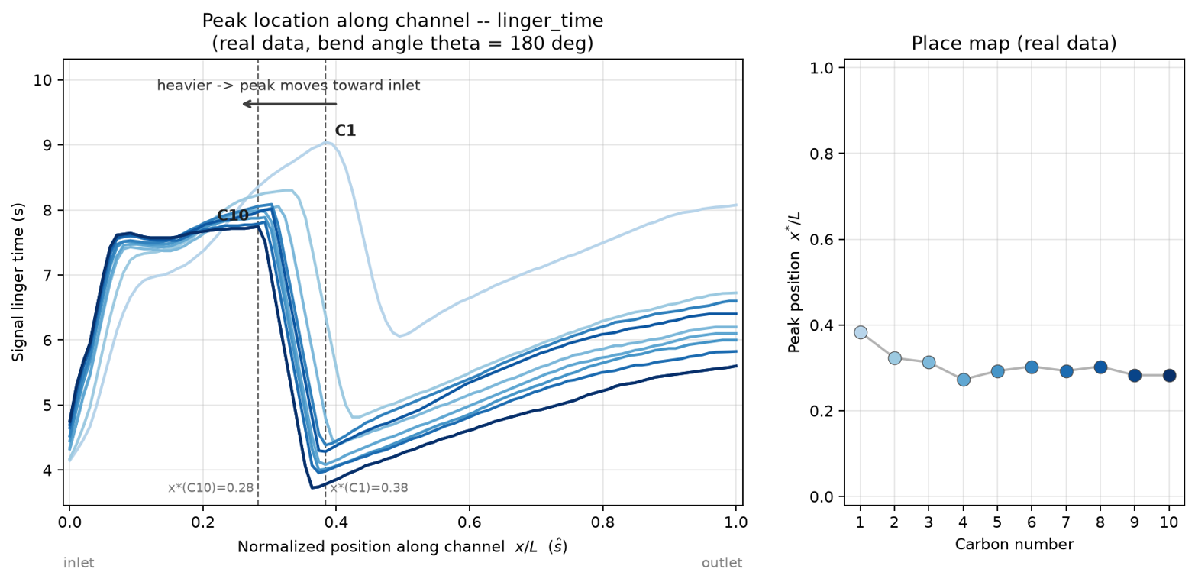  Early Place-Map Sweep, Later Superseded by Waveform-Timing Analysis | 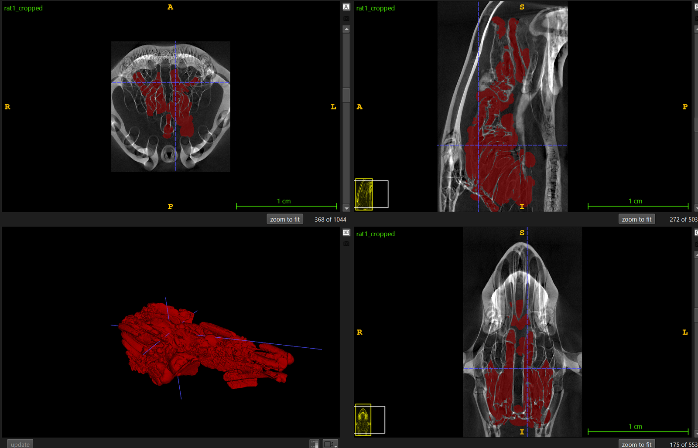  CT-Scanned Airway Segmented in ITK-SNAP
Midnight Sun Solar Car Ballast Box | SolidWorks, Sheet Metal, FEA, DFM/A, Waterjet Cutting
Designed an aluminum sheet-metal ballast box in SolidWorks to hold a minimum 20 kg of steel shot within a confined space on the chassis, sizing the interior from hand calculations with a 1.5 volumetric factor of safety. Iterated the geometry against static FEA under turning and braking load cases, converging on a 20% weight reduction with peak stress of about 34 MPa against the 55 MPa yield strength. Optimized the flat pattern for waterjet cutting and designed mounting tabs with weld nuts for easy assembly. Owned the box from first sketch through manufacture, and the finished assembly is on the competition vehicle.
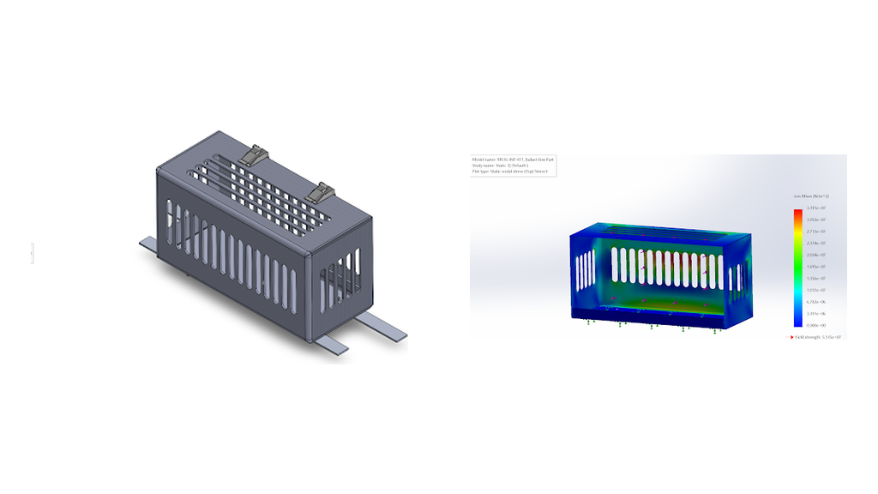  SolidWorks Model and FEA Results | 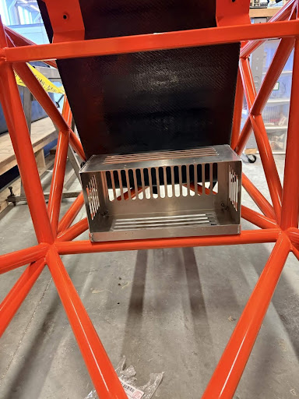  Manufactured Box Mounted in the Chassis
Pneumatic Piston Mounting Assembly Redesign | SolidWorks, Reverse Engineering, Technical Drawings
Redesigned a piston mounting assembly on a can production line where syrup splash built residue on the exposed rod, delaying actuation and causing mistimed can kickouts with monthly maintenance cleanups. Reverse-engineered the original plate, then adapted it to accept a replacement piston from a different vendor while preserving the original airline connections, so the assembly drops into the existing equipment. Designed a protective cover, fastened to side holes in the plate, to shield the rod from the splash that caused the problem while keeping maintenance access open. Delivered the SolidWorks models and a complete fabrication package with datum-based hole locations, tolerances, slot geometry, and thread and countersink callouts.
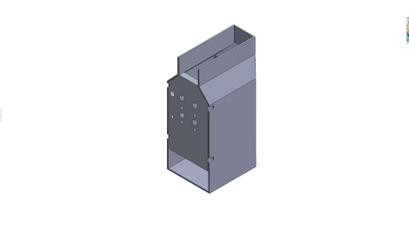  SolidWorks Model of the Full Assembly | 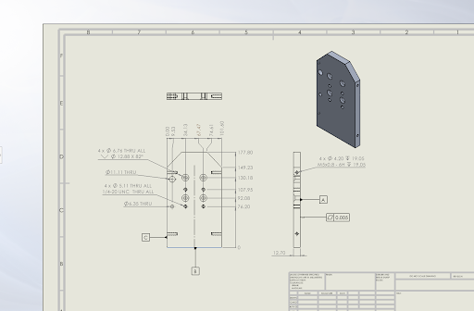  Fabrication Drawing of the Mounting Plate
WAC-A-MOLD Injection Molder – Clamping Subsystem | Onshape, SolidWorks, Parametric Design, Linkage Design, Machining
Leading the clamping subsystem of a desktop injection molder as one of the core founding members of the Waterloo Automation Collective, a design team started with a group of 10 students. Parametrized the clamping-unit linkages as fully variable-driven models in Onshape and SolidWorks, which accelerated design iteration and centralized configuration management across the team. Machining the links on a mill to carry the design into physical prototypes; the machine is early-stage and performance numbers will follow prototype testing.
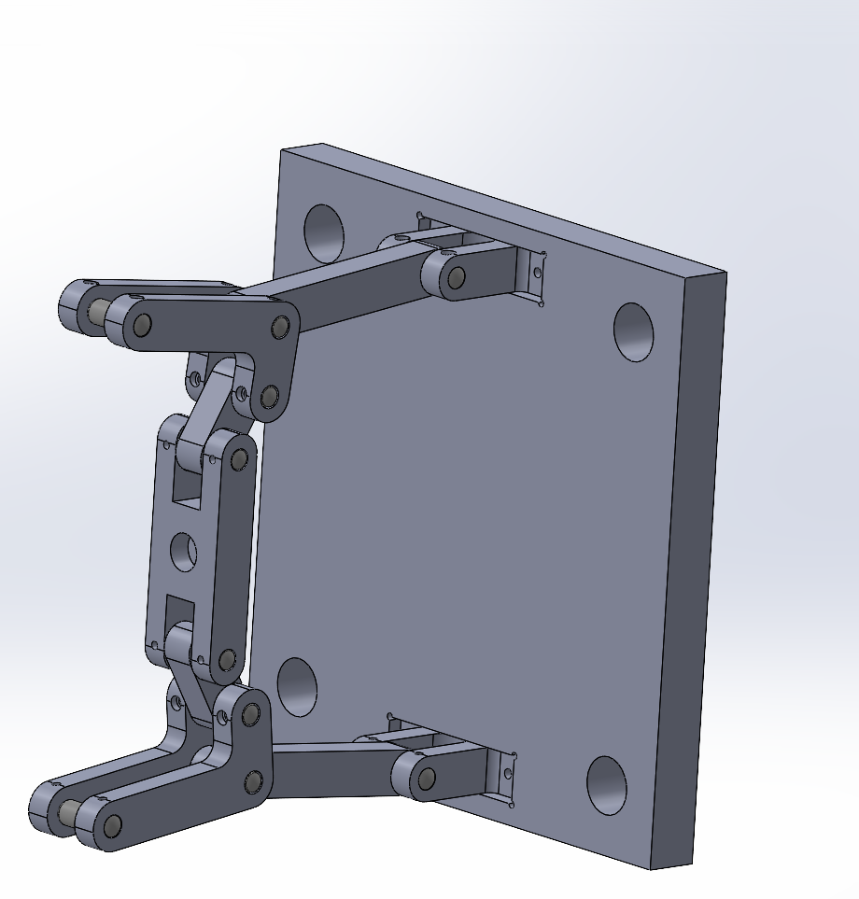  Toggle Linkages (My Subsystem) | 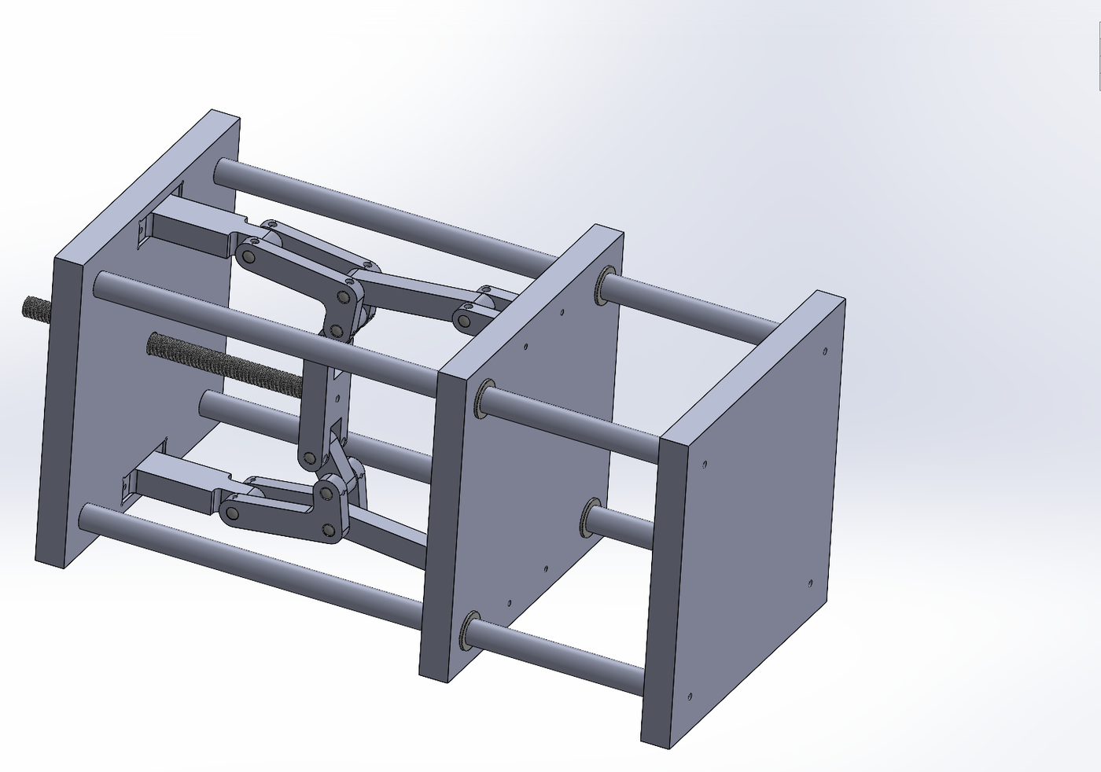  Full Clamping Unit
Midnight Sun Solar Car: Wheel-Cover Stencils and Camera Mounts | Surface Modeling, Datum-Referenced Fixturing, Press-Fit Design, FDM 3D Printing
Designed two assembly fixtures for the solar car. Surface-modeled wheel-cover cutting stencils that follow the curvature of the dynamic aerobody, datumed to the ribs of the car so cut position is a property of the tool rather than the installer; the stencil design was approved for use on the vehicle. Designed a tool-free press-fit camera mount system for FDM 3D printing that replaced the bolted-in mounts of previous years, gripping the inner edge of the rear windshield frame with press-fit dimensions converged over 5 PLA print iterations, keeping the camera accessible for maintenance.

